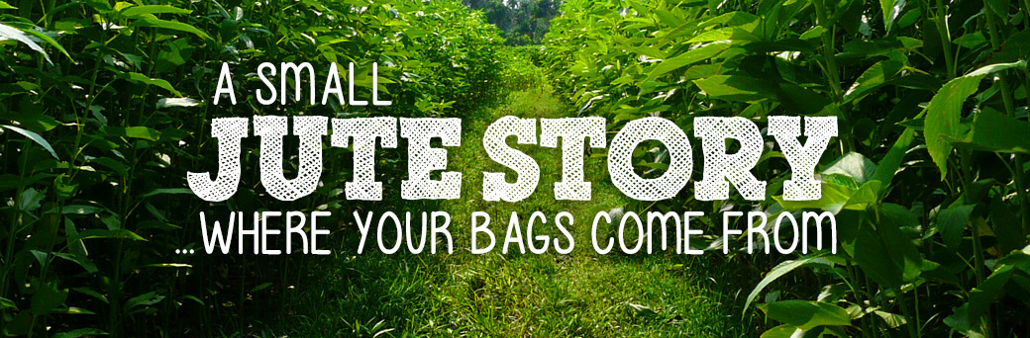
https://gojute.co.uk
SHOULD

Jute is a natural fibre and one of the strongest around. Traditionally farmed, it is grown in similar conditions to organic farming. The jute plant is rotated, while NO pesticides or fertilisers are used in the growing process and nothing is Genetically Modified.
Jute is mainly grown in the Bengal area of India and grows fully in 4-6 months.
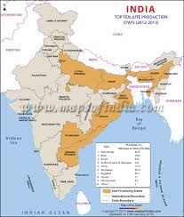

History

For centuries, jute has been an integral part of the culture of Bengal. Since the seventeenth century the British started trading in jute. British jute barons grew rich processing jute and selling manufactured products made from jute. More than a billion jute sandbags were exported from Bengal to the trenches during World War I and also exported to the United States southern region to bag cotton. It was used in the fishing, construction, art and the arms industry. The industry boomed throughout the eighteenth and nineteenth centuries, but this trade had largely ceased by about 1970 due to the emergence of synthetic fibers. In the 21st century, jute again rose to be an important crop for export in contrast to synthetic fiber, mainly from Bangladesh. (from Wikipedia)

Jute is the second most important vegetable fibre after cotton, not only for cultivation but also for various uses:
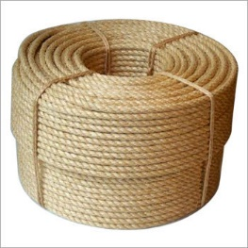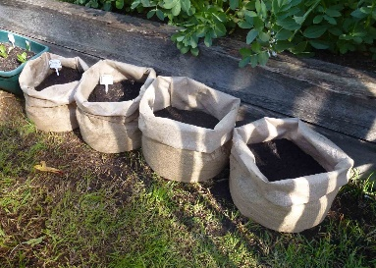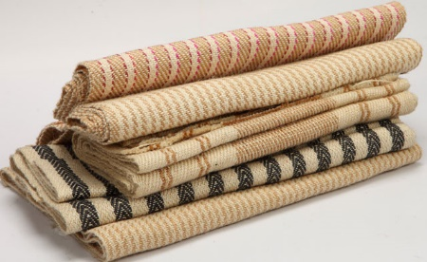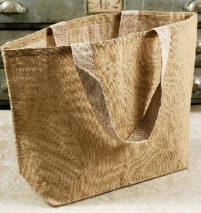

Golden Fibre
Jute is a rain-fed crop with little need for fertilizer or pesticides, in contrast to cotton’s heavy requirements. Jute plant needs a plain loose soil and standing water. The suitable climate for growing jute (warm and wet) is offered by the monsoon climate, during the monsoon season. Temperatures from 20˚C to 40˚C and relative humidity of 70%–80% are favourable for successful cultivation. Jute requires 5–8 cm of rainfall weekly, and more during the sowing time.
Jute fiber has a length of 1 to 4 m and is soft and shiny, hence called the Golden Fibre. Jute fibre is 100% bio-degradable and recyclable and thus environmentally friendly. A hectare of jute plants consumes about 15 tonnes of carbon dioxide and releases 11 tonnes of oxygen. Cultivating jute in crop rotations enriches the fertility of the soil for the next crop. Jute also does not generate toxic gases when burnt.
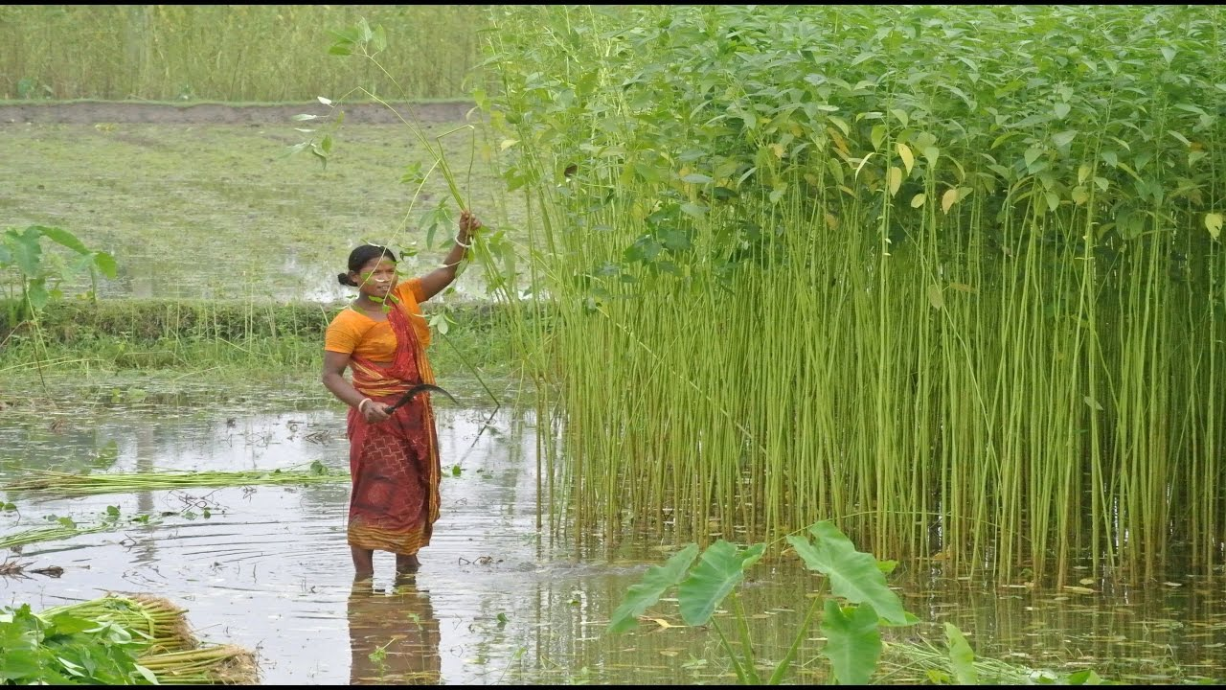

Videos on Jute:
https://www.youtube.com/watch?v=wwnISex9tPs: Manas Banaerjee, jute farmer from Balurghat, South Dinajpur of West Bengal talks about different varieties of jute that are cultivated in West Bengal and aspects of jute cultivation (English subtitles, 5.19 min.)
https://www.youtube.com/watch?v=-1LFc6OB-xQ: Jute – the fibre of the future (English, 18.26 min.)
https://www.youtube.com/watch?v=Q_JjgaU5uq4: Jute the golden fibre of India (English, 4.25 min)
Task:
- Look around in your neighbourhood: Which plastic products could be replaced by jute?
- Where can you purchase jute products?
- What is the price difference between the jute products and similar plastic products?
- Try out how many times the jute and plastic products can be used again.

gjunne@gmail.com

