Creating Effective Networks - Week 8 - (3 – 9 December 2012) - LEARNING

1. We probably all work in a setting which has more or less internalized the institutional learning cycle, but did we also see future-oriented learning processes in our work environment?
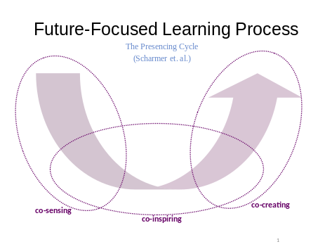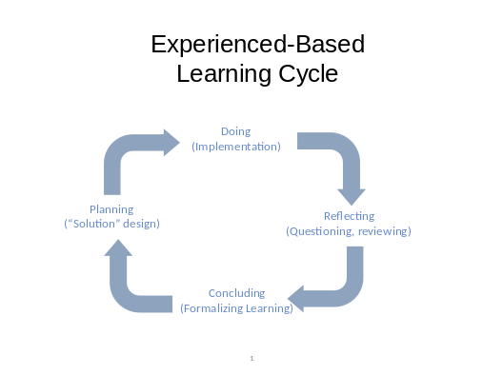

2. How does your network organize learning?
- Is there a plan which knowledge needs to be acquired? By whom?
- What is the “radar system” of the network that signals changes in the environment?
- How is development of competencies integrated into daily practices? (Waddell, p.192)
- What are the most valuable sources of knowledge and experience – are they fully used?
- How well are learning results “captured”, shared and documented?
- Is the knowledge acquired acted upon?
- What do people formally responsible for learning do? (Do they exist?)
- How is “Retaining of Critical Knowledge” (Shell’s “ROCK”) organized?

3. Learning means change. It often implies “un-learning”. What is your most recent experience with “un-learning”?
4. I like the expression “working wikily” (Waddell, p. 196), i.e. in a way which continuously integrates lessons learnt into further action. In which way have such routines been developed in your network?
5. Who is actually learning when “the network is learning”? The secretariat? The board? The members? Committees? The “top-dogs”? Rank and file?
6. There are structures that support learning and structures that impede it. Power is “the privilege not to have to learn”. (Karl W. Deutsch) What is your experience with dealing with power differences in networks? (cf. Waddell p. 190-191)
7. Does the “learning ecology” provide a useful framework for developing learning networks? (p. 192)
8. Is there any experience in your work environment with an “alignment of reward systems” (Waddell p. 192) to stimulate learning?

